Tentative Program
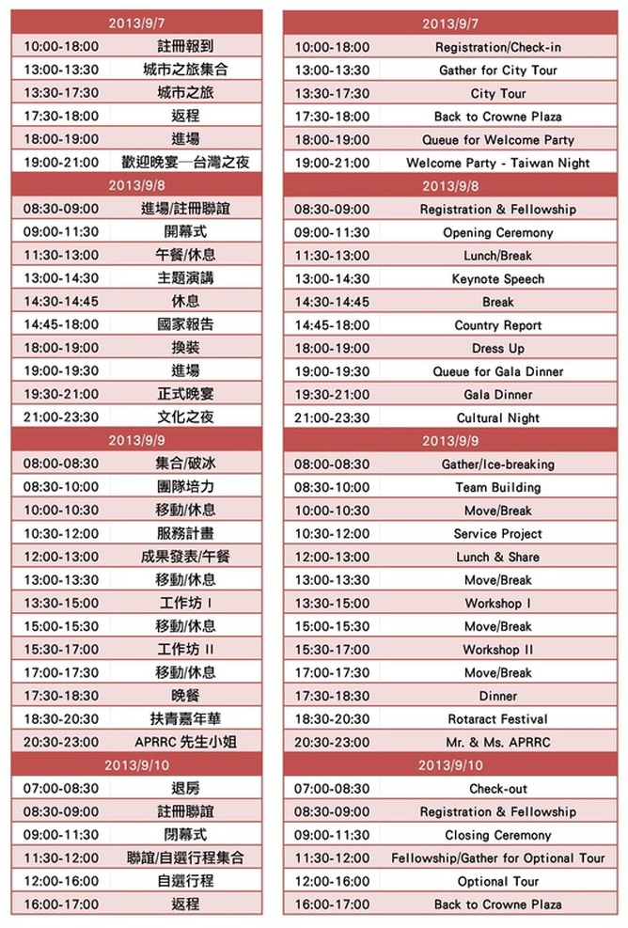
The Organizer reserves the right to add, modify, define, and verify the program of above.
以上內容主辦單位保留依照需求新增、修改、解釋與審核之權利。

註冊費
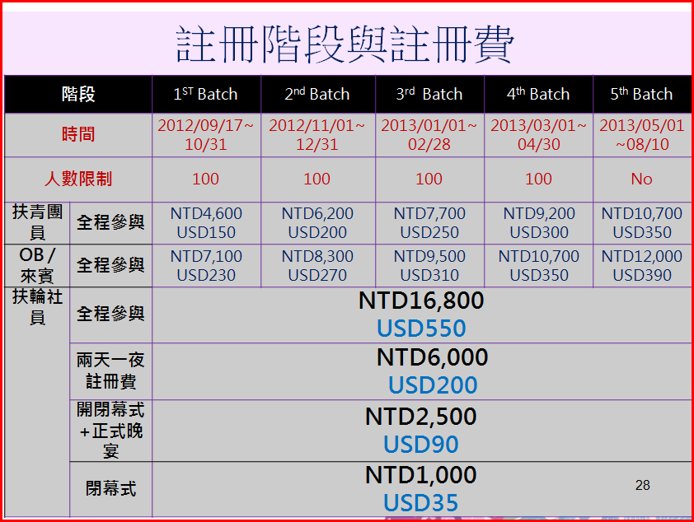

Each registration fee does not include the cost of: Shuttle Service and Optional Tours.
各項註冊費用皆不含會場專車及自選行程。

http://www.aprrc2013.org

